SilkPath User Manual

Overview

SilkPath is a tool for users to keep track of their dating diaries. A user can sign up for SilkPath, and log in when they come back to the tool after they have signed up. The user can then add a diary. In a diary, they can enter details such as match’s name, age, blurb, dating date, place and notes, also upload a photo. The diary created by the user will show up in the main page. They can click and view the diary, as well as their match’s profile. The user can also delete a diary and the match associated with that diary.

Program Flow

* To run the program, simply click on “run” in Eclipse. The user will be prompted to the first screen to select sign up or log in options.

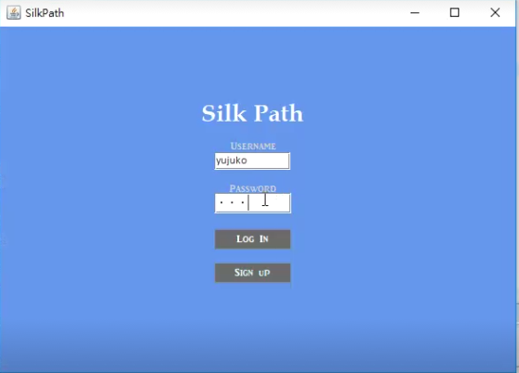

* If user never sign up before, a message will show up and ask them to sign up.

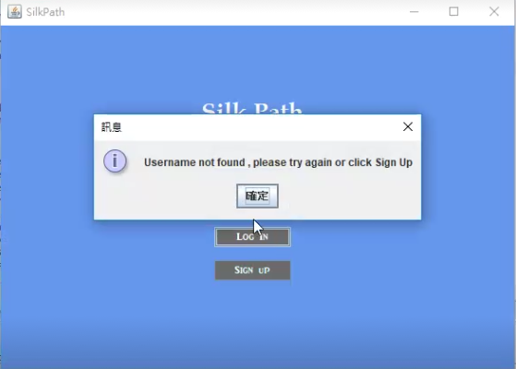

* At the sign up page, if the passwords are not the same, they will be asked to enter the passwords again.

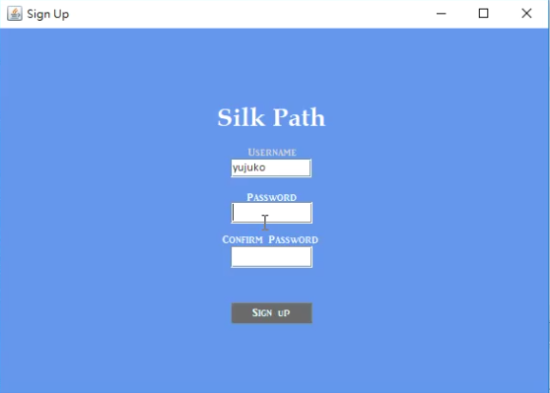

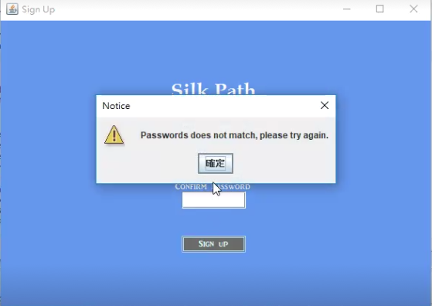

* After they successfully signed up/ logged in , their diaries history will show up (if any).



* When they click “ADD NEW DIARY”, a window will show up and they can enter the detail of the date. Details are Match name, age, blurb and a photo of the match. Also the details of the date like the place and date, notes.

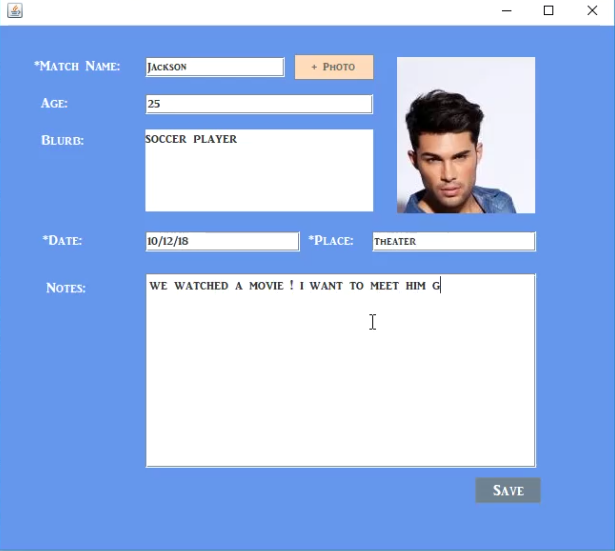

* After saved, the home page will show up all the diaries they created.

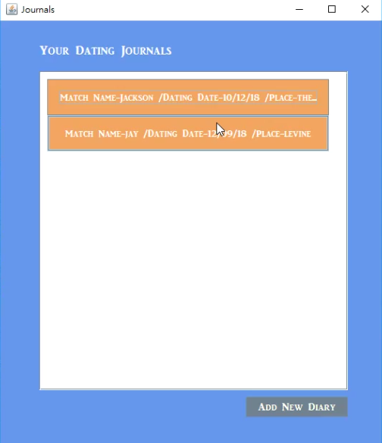

* When they click the diaries, dating details will show up in another window.

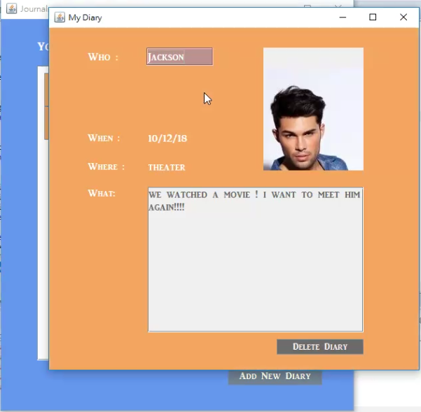

* They can view the match’s profile by clicking the name in the diary.

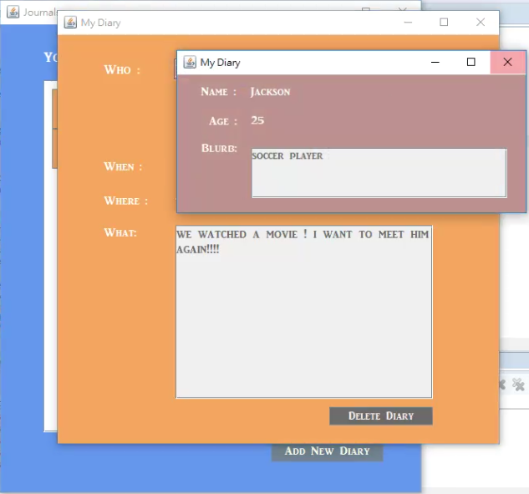

* Diaries are allowed to be deleted by clicking “DELETE DIARY” . Then homepage would be updated.

